FOOD MANAGEMENT SYSTEM

Use-Case Specification: Display order status

Version <1.0>

Revision History

|  |  |  |  |
| --- | --- | --- | --- |
| **Date** | **Version** | **Description** | **Author** |
| <7/12/2020> | <1.0> | <details> | <Nguyen Thu Trang> |

Table of Contents

1. Use-Case Name 4

1.1 Brief Description 4

2. Flow of Events 4

2.1 Basic flow 4

2.2 Alternative flow 4

2.2.1 <First Alternative flow> 4

2.2.1 <Second Alternative flow> 4

3. Special Requirement 4

3.1 <First Special Requirement> 5

4. Preconditions 5

4.1 <Precondition One> 5

5. Posstcondition 5

5.1 <Postcondition One> 5

6. Extension Points 5

6.1 < Name of Extension Points> 5

Use-Case Specification: Display order status

1. **Use-Case name**
   1. **Brief Description**

This use case defines the view of order. The system allow customer and admin view the order status.

* 1. **Actor**

Customer, admin

1. **Flow of Events**
   1. **Basic Flow**

First, customer and admin login the system and then click on click “View order status” on interface view selected products. The system display  information of this order status in detail.

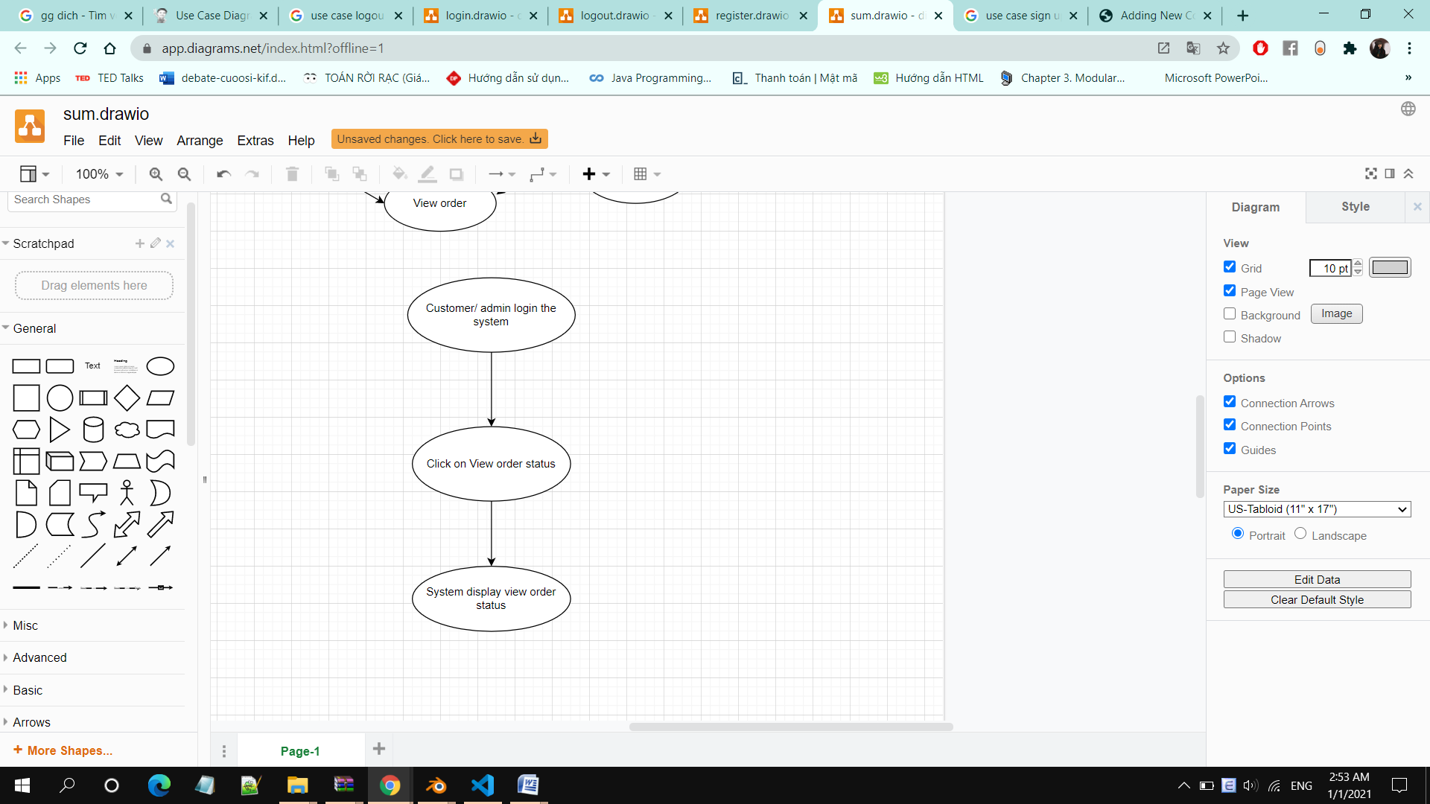

1. **Special Requirements**

Customer, admin must know how to use the product management system.

1. **Preconditions**

Customers have ordered successfully

1. **Postconditions**

No postconditon

1. **Extension Points**

No extension points.